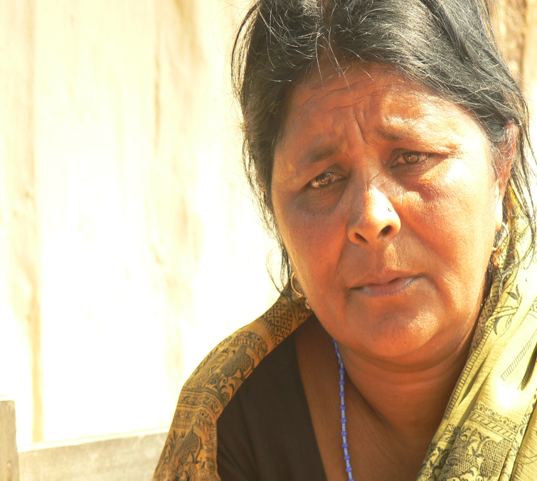
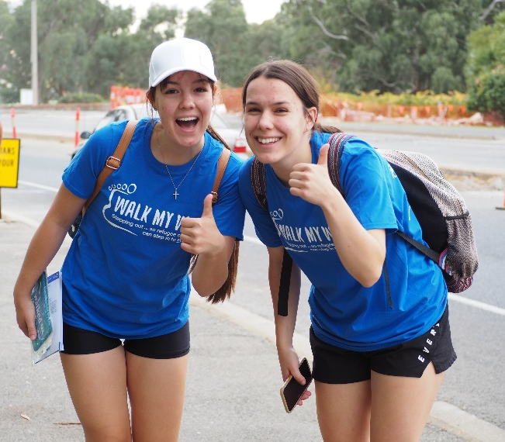
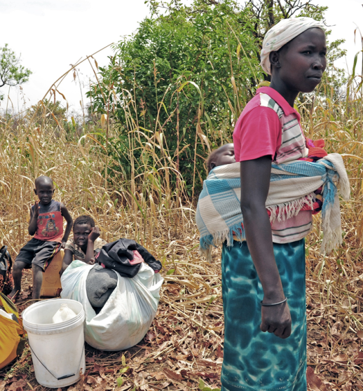

Australian Lutheran World Service
Strategic Plan 2021 to 2026
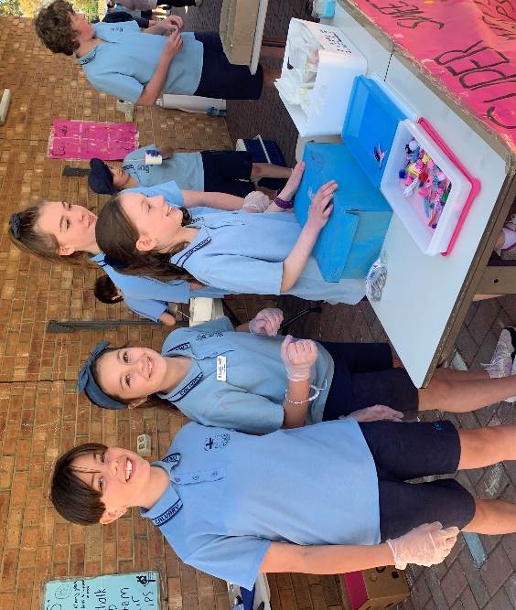
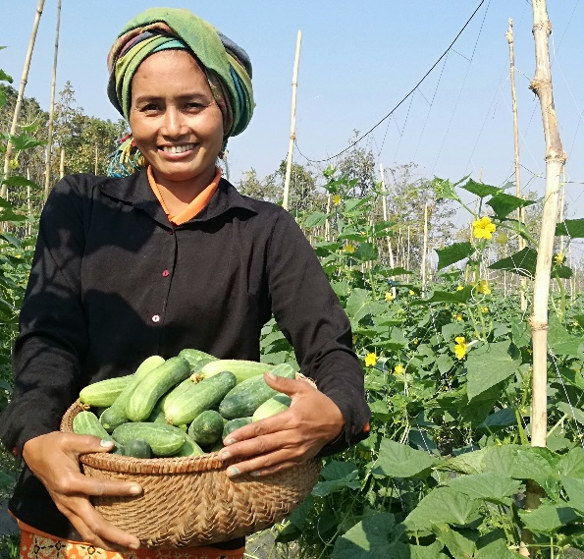
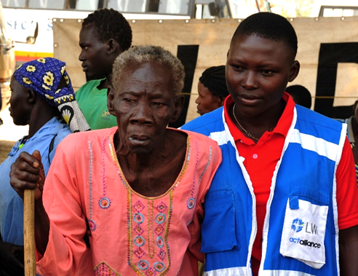

Introduction
Australian Lutheran World Service (ALWS) is the aid and development agency of the Lutheran Church of Australia and New Zealand (LCANZ). This Strategic Plan outlines ALWS’ Mandate, Vision, Mission, and Guiding Principles. It articulates the Change We Want to See, our Approach, and the Goals and Outcomes we are seeking to achieve from 2021 to 2026.

In this strategic period, ALWS will continue to contribute to many of the strategic priorities of the LCANZ, including:
- Objective 1.3 Equip people for mission and ministry in the church, local communities and the wider world (Goals 1-3)
- Objective 1.5 Protect and uphold the dignity of people, especially children and the vulnerable, to lead lives in peace and safety (Goal 1)
- Objective 3.3.4 Encourage greater support for the work of the church using innovative approaches (Goals 1-3)

Our Mandate
We love because God first loved us. Jesus said, “For I was hungry, and you gave me something to eat; I was thirsty, and you gave me something to drink; I was a stranger, and you invited me in; naked, and you clothed me; I was sick, and you visited me; I was in prison, and you came to me… Truly I say to you, to the extent that you did it to one of these brothers or sisters of mine, even the least of them, you did it to me.” (Matthew 25:35-36,40).

Our Vision
ALWS envisages a world where love comes to life (see 1 John 4:9-12); a world where all people live in just societies, where we are all empowered to achieve our full potential, uphold our rights and the rights of others for a life with peace and dignity; and where we are all inspired to remember, welcome and support those who suffer from poverty and injustice (see Galatians 2:10 and Leviticus 25:35).

Our Mission
ALWS reaches out in love, for justice. We bring together people willing to work in service to help end suffering. As partners, we work openly and accountably, supporting programs which welcome, respect and bring hope through care to those fleeing from, or hurt by, disaster, conflict, poverty or oppression. We add our voice to the voices of those unheard and excluded, together crying out for justice so that we can all live in just and sustainable communities.

Our Guiding Principles
— we serve with unconditional love
— we work in partnership
— we support the inclusion of all people
— we make good use of God’s gifts
— we work for the empowerment of others
— we are accountable
— we respect and uphold people’s dignity
— we value the people who work with us
— we work for justice
— we value reflection
— we care for God’s creation
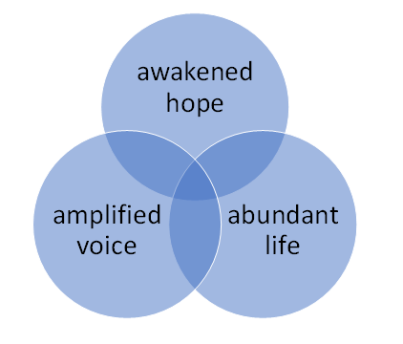
The Change We Want to See
Our work is focused on enabling the people we serve to experience awakened hope, amplified voice and abundant life:

- awakened hope – fostering hope for the future through empowerment of, and practical support for, people at risk of being forgotten

- amplified voice – listening to the voices of the most vulnerable, fostering opportunities for them to speak up, and adding our voice, so that they may be heard

- abundant life – equipping people with the resources they need to create a fulfilling life for themselves and their communities

Our Approach

Don’t forget those who are suffering
but imagine that you are there with them.
Hebrews 13: 2-3

Drawing on this scriptural reference and considering the alarming rise in inequality in our world, this strategic period we will focus on supporting those who are on the move and affected by disaster in the Asia-Pacific and Sub-Saharan Africa. Within these groups, we will intentionally seek out those most at risk of abuse, exclusion and inequality and those who experience disadvantage due to gender or disability.

In this plan we refer to people who may be marginalised, disenfranchised, excluded and abused as ‘those at risk of being forgotten’ as well as speaking of the ‘most vulnerable’. We will deliberately invest in partnerships and collaborations that seek to reach these groups. We will inspire and equip people to support work which is rights-based, sustainable, and integrated.

ALWS tracks and measures its contribution to this critical global effort through Board agreed organisational-based outcomes. We track our performance towards each of these outcomes by measuring certain indicators of success, outlined in our Operational Plan.

AUSTRALIAN LUTHERAN WORLD SERVICE
STRATEGIC PLAN 2021-2026

GOAL 1:  Life-changing action led by those we serve | GOAL 2:  Australians inspired to joy-filled action
Outcome 1.1:  ALWS and partners have sought, welcomed and supported those who are most vulnerable and at risk of being forgotten.  Outcome 1.2:  ALWS has supported partners to include, protect and enhance the capacity of the most vulnerable.  Outcome 1.3:  The most vulnerable are empowered with enhanced skills for life, livelihoods and leadership. | Outcome 2.1:  ALWS has grown its resources to increase action for those who are most vulnerable and at risk of being forgotten.  Outcome 2.2:  ALWS thrives on the trust of the extended Australian and New Zealand Lutheran family who make ALWS their aid and development agency of choice.  Outcome 2.3  People are equipped to bring love to life and amplify the voices of those who are most vulnerable and at risk of being forgotten by the world.
GOAL 3:
Resources maximised for those who need it most
Outcome 3.1: Staff, Board and volunteers are engaged and well-equipped for their roles.

Outcome 3.2: ALWS maximises key partnerships for increased reach and impact.

Outcome 3.3: ALWS is a sustainable, best-practice agency optimising efficiency and effectiveness.

awakened hope … amplified voice … abundant life

